**A**

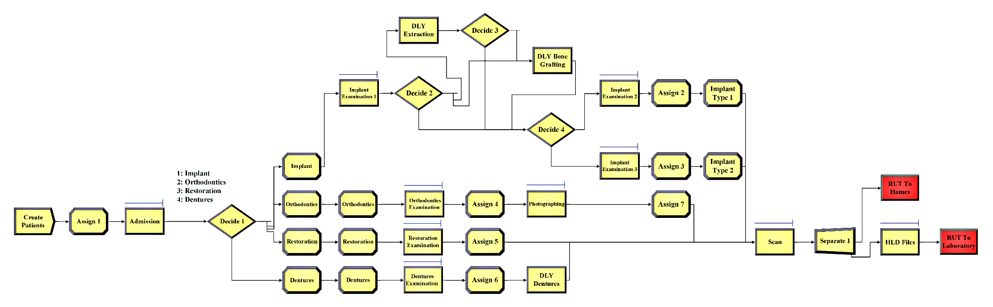

**Figure A.** A full view of the clinic-related procedures simulation model before 3DP

**B**

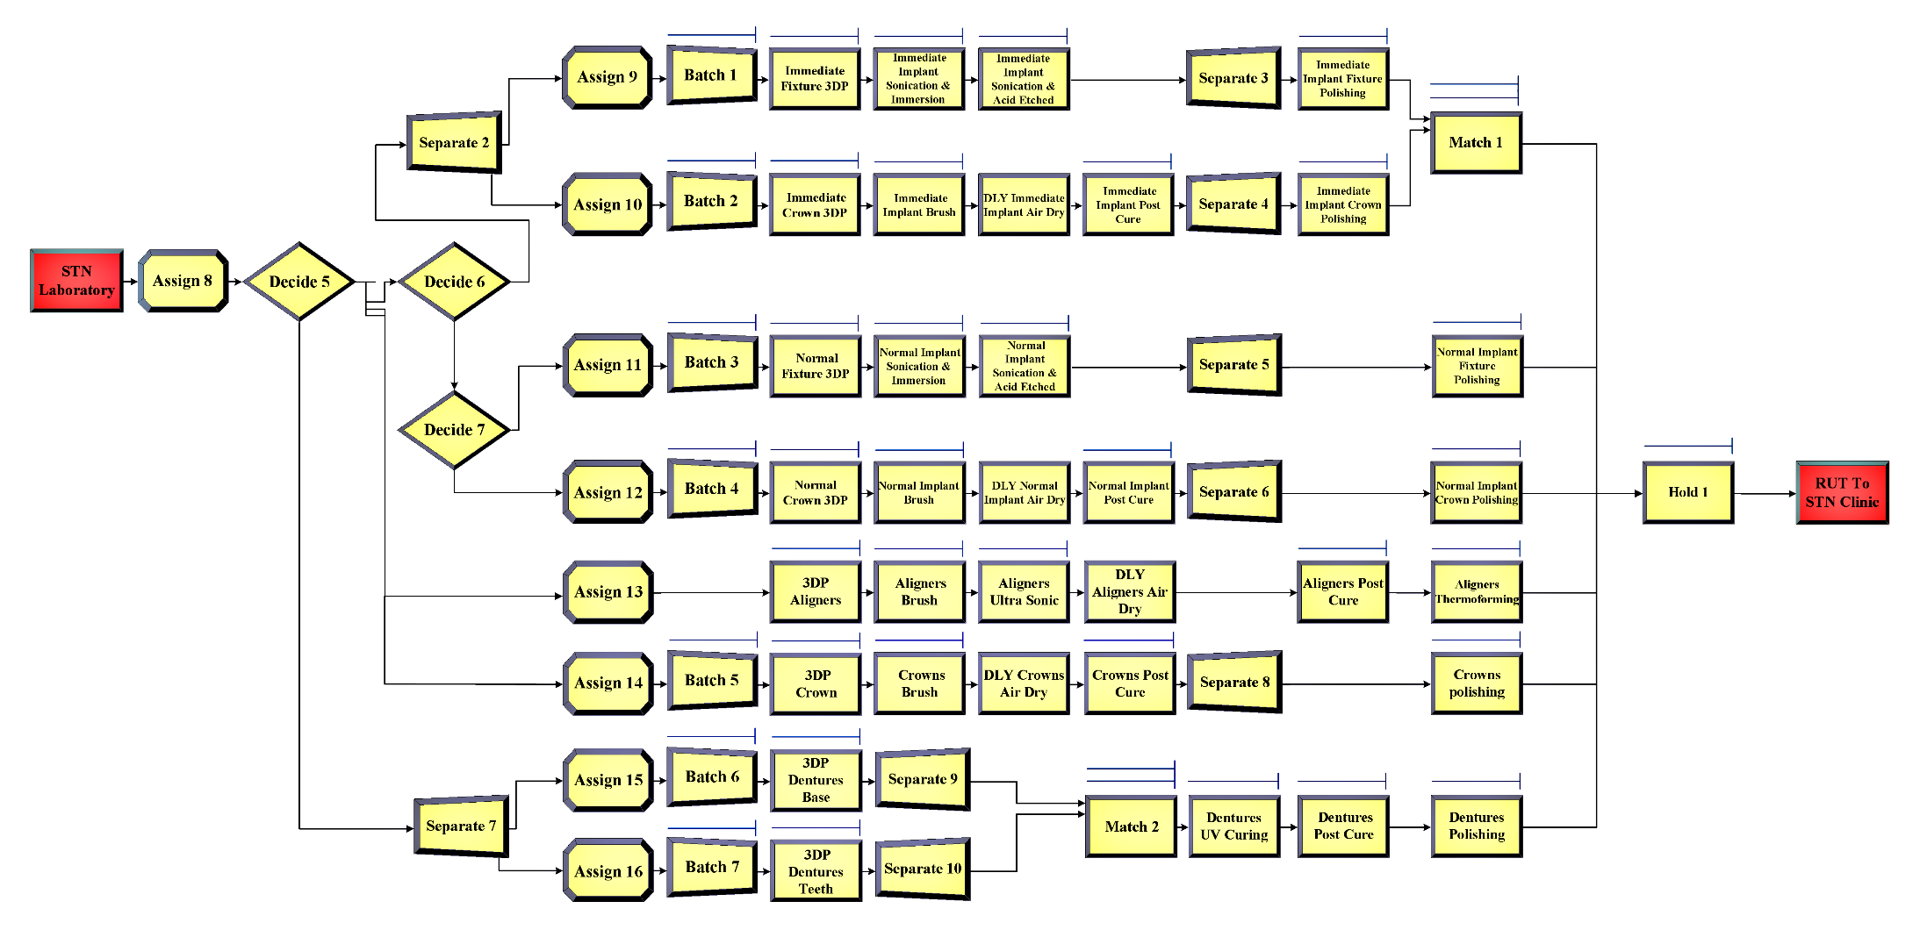

**Figure B.** A full view of the laboratory-related procedures simulation model

**C**

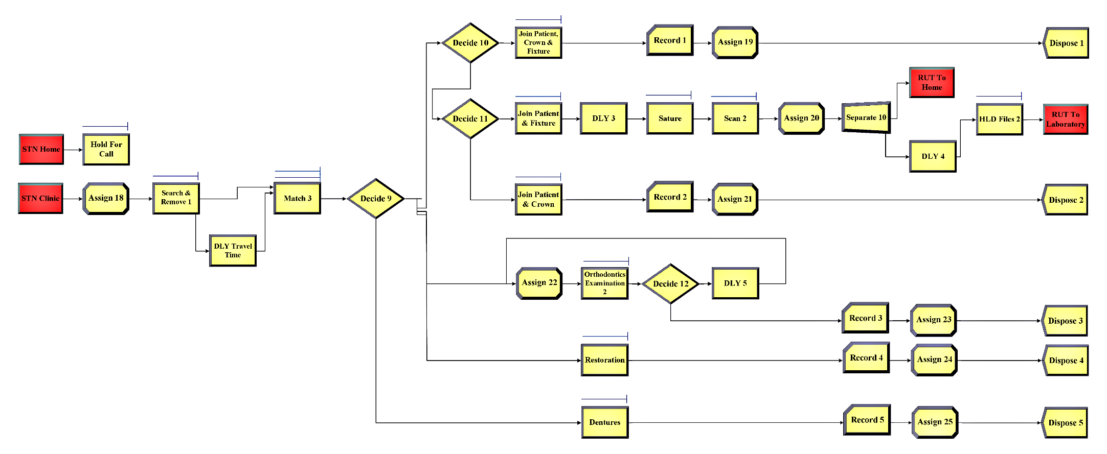

**Figure C.** A full view of the clinic-related procedures simulation model after 3DP

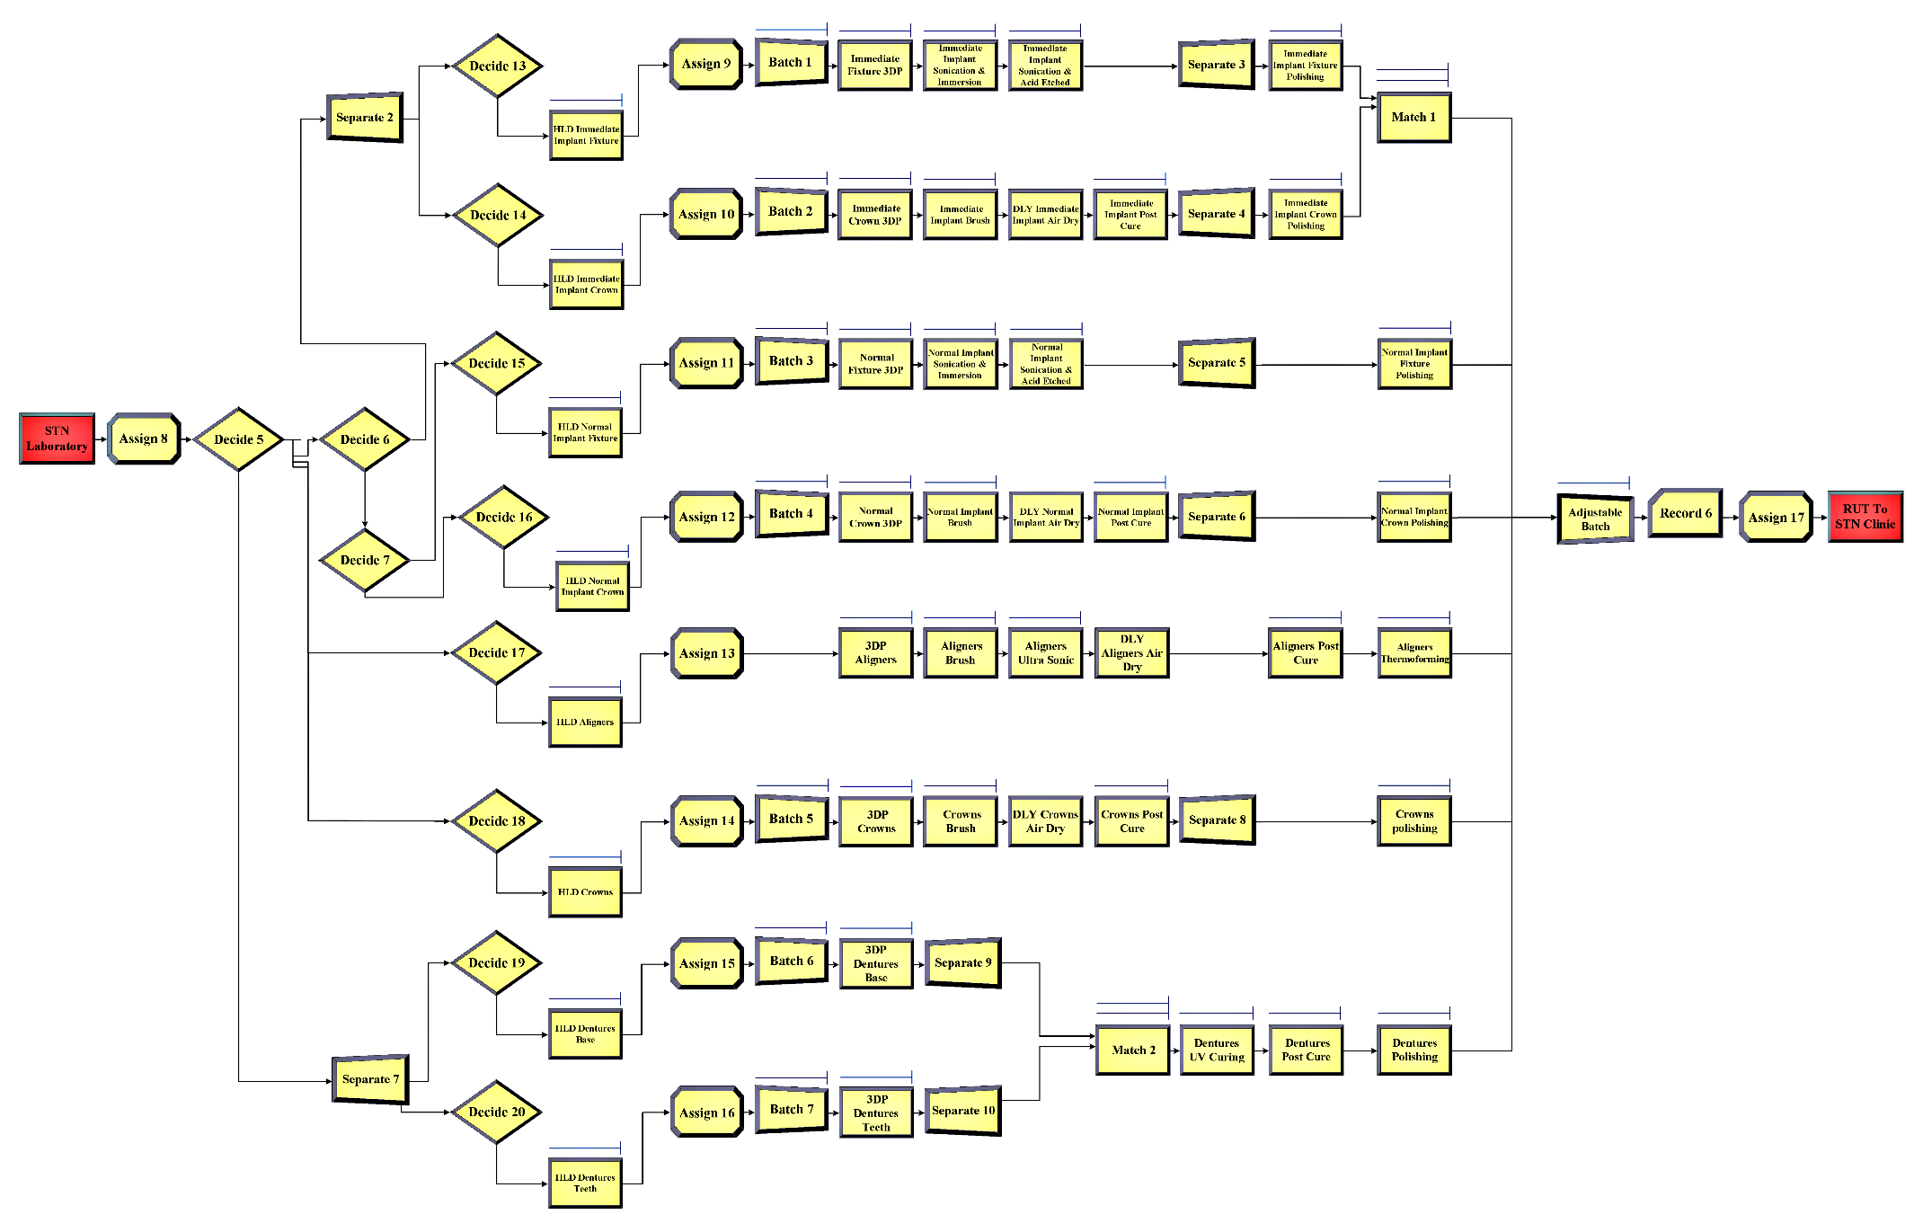**D**

**Figure D.** A full view of the laboratory-related procedures simulation model with innovation

**E**

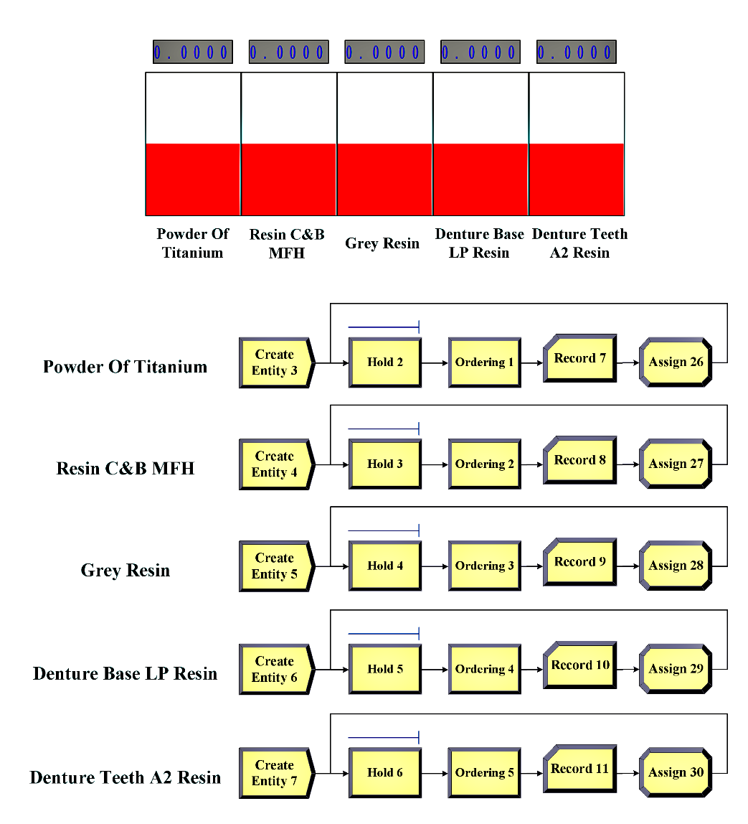

**Figure E.** A full view of the laboratory’s ordering policy simulation model